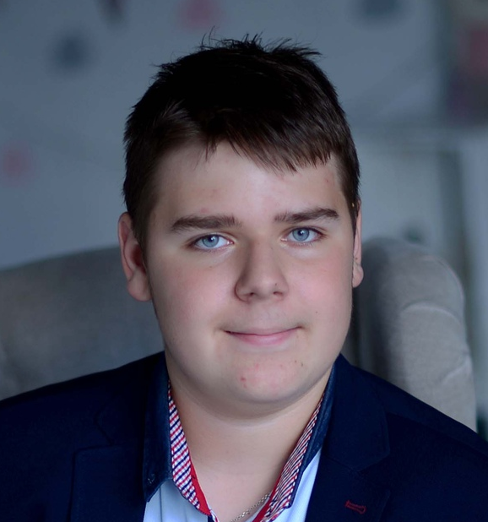

Contact information

|  |  |  |  |  |
| --- | --- | --- | --- | --- |
| Phone: +380502502463  Email: ruschakartur@gmail.com  Skype: artur.ruchak | | | Artur Ruschak | |
|  | | 28.12.2002  Frontend(Angular) developer | | |
|  | | | | |
| Summary of Qualifications | Frontend developer.  Know some backend(Java , C++,php).  Starting learn python  Can work with Git. | | | |
|  | | | | |
| Skills | **Programming Languages/ Technologies**   * Html(9/10) , CSS(9/10), JavaScript(6/10), PHP(3/10) * Python(6/10), C++(4/10), Java(5/10) * Preprocessors(SCSS, LESS)   **Libraries**   * Bootstrap4(6/10) * jQuery(4/10) * PrimeNG(7/10) * Slick(slider)(8/10) * Animate.css(8/10) * WOW(7/10) | | | **Frameworks**   * Angular(6/10) * Django(4/10)   **Development Tools**   * Eclipse/MyEclipse & Plug-ins(6/10) * WebStorm(7/10) * Git(8/10) * Trello(6/10)   **CMS**   * WordPress(6/10) |
|  |  | | | |
| Experience / IT related educational practice | I don’t have any work experience | | | |
|  |  | | | |
|  |  | | | |
|  |  | | | |
|  |  | | | |
| Languages | English – Pre-Intermediate | | | |
|  | | | |
|  | | | |
|  |  | | | |
| Education | School №12.  2009-2020 | | | |
|  | | | |

|  |  |  |
| --- | --- | --- |
| Additional education (courses, trainings) | ITCluster academy ( Js + Angular)  In process : ITCluster academy(Python) | |
|  | | |
| Hobbies | Computer games, basketball, reading, music |  |